**We installed Java 8 from the official site using following steps**

This Java Development Kit(JDK) allows you to code and run Java programs.

## **How to install Java for Windows**

Following are the steps on how to install Java in Windows 10 for JDK 8 free download for 32 bit or JDK8 download for Windows 64 bit and installation

****Step 1)**** Go to [link](https://www.oracle.com/java/technologies/javase-downloads.html). Click on JDK Download for Java download JDK 8.

[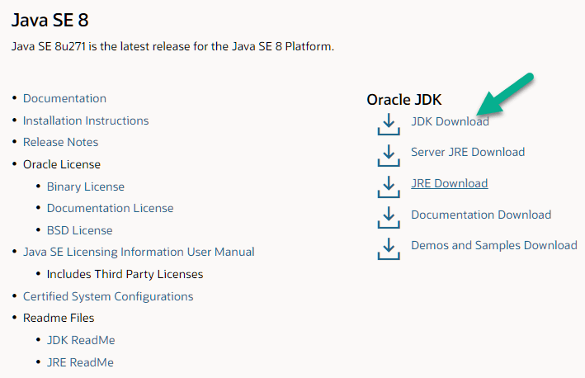](https://cdn.guru99.com/images/2/javainstall-1.png)

How to write a TEST CASE Software Testing Tutorial

****Step 2)**** Next,

1. Accept License Agreement
2. Download Java 8 JDK for your version 32 bit or JDK download 64 bit.

[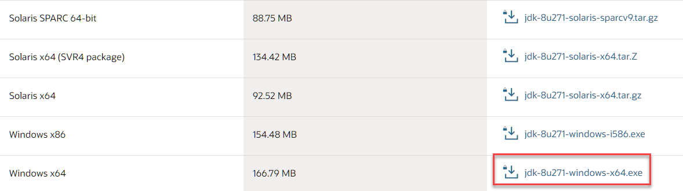](https://cdn.guru99.com/images/2/javainstall-2.png)

****Step 3)**** When you click on the Installation link the popup will be open. Click on I reviewed and accept the Oracle Technology Network License Agreement for Oracle Java SE development kit and you will be redirected to the login page. If you don't have an oracle account you can easily sign up by adding basics details of yours.

[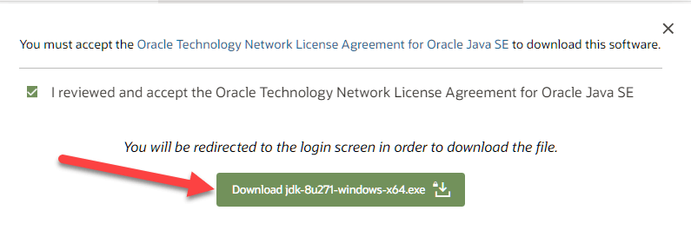](https://cdn.guru99.com/images/2/javainstall-3.png)

****NOTE:**** You will be required to create an Oracle Account to start Java 8 download of the file.

****Step 4)**** Once the Java JDK 8 download is complete, run the exe for install JDK. Click Next

[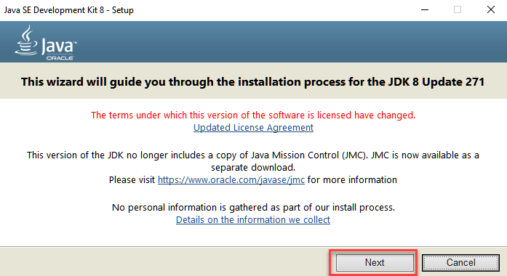](https://cdn.guru99.com/images/2/javainstall-4.png)

****Step 5)**** Select the PATH to install Java in Windows… You can leave it Default. Click next.

[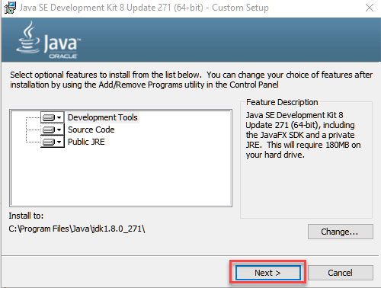](https://cdn.guru99.com/images/2/javainstall-5.png)

****NOTE:**** Follow the onscreen instructions in succeeding steps to install Java 8 on Windows 10.

****Step 6)**** Once you install Java in windows, click Close

[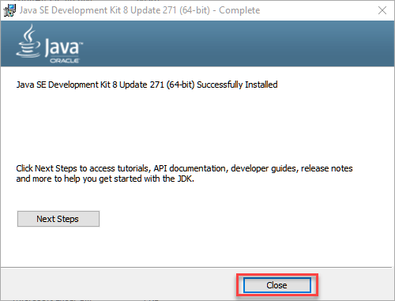](https://cdn.guru99.com/images/2/javainstall-6.png)

## **How to set Environment Variables in Java: Path and Classpath**

The PATH variable gives the location of executables like javac, java etc. It is possible to run a program without specifying the PATH but you will need to give full path of executable like ****C:\Program Files\Java\jdk1.8.0_271\bin\javac A.java**** instead of simple ****javac A.java****

The CLASSPATH variable gives location of the Library Files.

Let's look into the steps to set the PATH and CLASSPATH

****Step 1)**** Right Click on the My Computer and Select the properties

[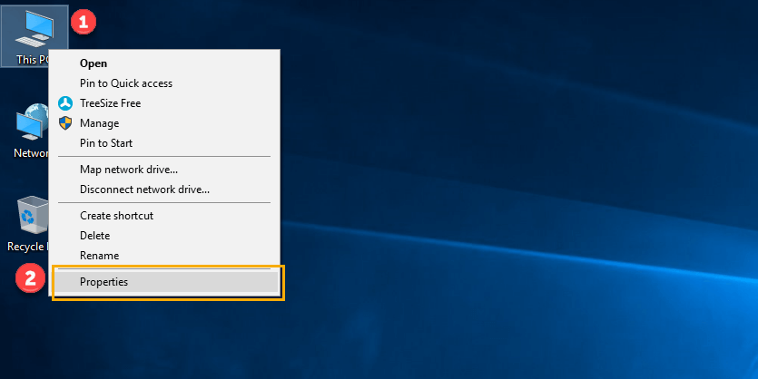](https://cdn.guru99.com/images/java/111417_1107_Java25.png)

****Step 2)**** Click on advanced system settings

[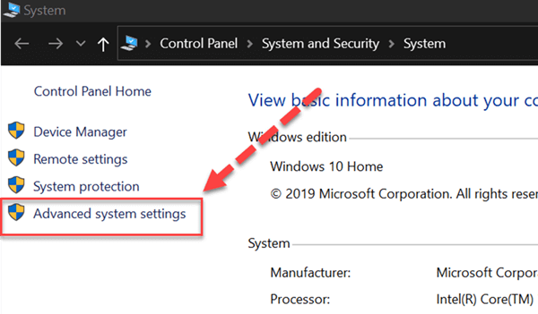](https://cdn.guru99.com/images/2/java-install-20.png)

****Step 3)**** Click on Environment Variables to set Java runtime environment

[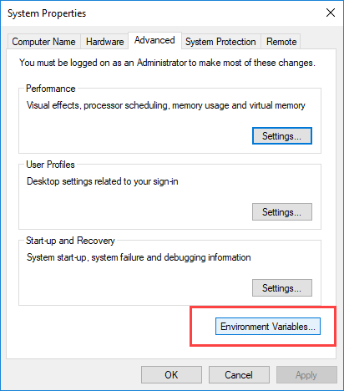](https://cdn.guru99.com/images/java/111417_1107_Java27.png)

****Step 4)**** Click on new Button of User variables

[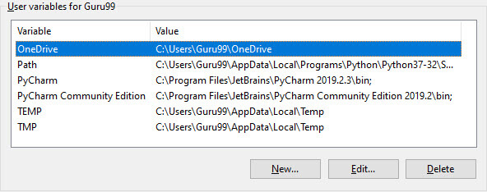](https://cdn.guru99.com/images/java/1912211_install_javaimage9.jpg)

****Step 5)**** Type PATH in the Variable name.

[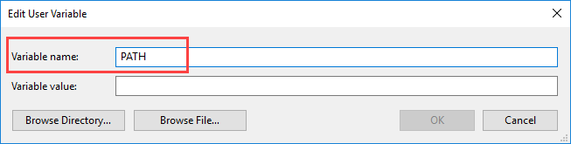](https://cdn.guru99.com/images/java/111417_1107_Java29.png)

****Step 6)**** Copy the path of bin folder which is installed in JDK folder.

[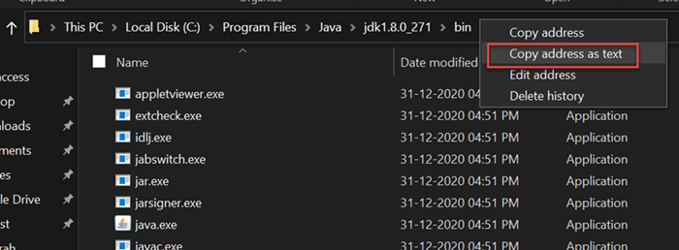](https://cdn.guru99.com/images/2/java-install-21.png)

****Step 7)**** Paste Path of bin folder in Variable value. Click on OK Button.

[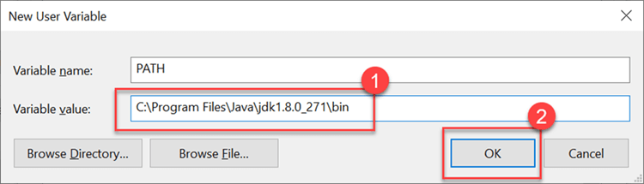](https://cdn.guru99.com/images/2/java-install-22.png)

****Note:**** In case you already have a PATH variable created in your PC, edit the PATH variable to

PATH = <JDK installation directory>\bin;%PATH%;

Here, %PATH% appends the existing path variable to our new value

****Step 8)****You can follow a similar process to set CLASSPATH.

[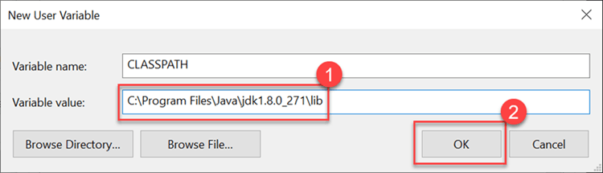](https://cdn.guru99.com/images/2/java-install-23.png)

****Note:**** In case you java installation does not work after installation, change classpath to

CLASSPATH = <JDK installation directory>\lib\tools.jar;

****Step 9)**** Click on OK button

[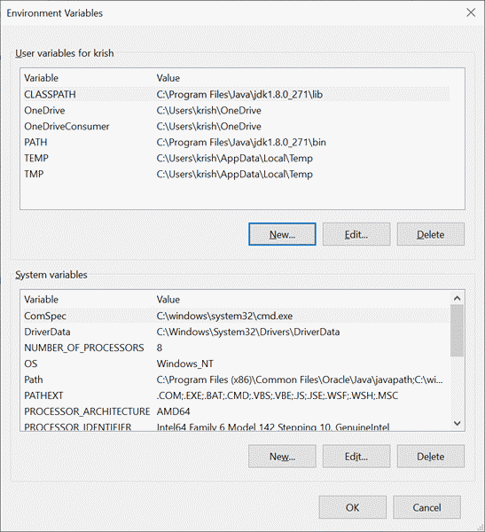](https://cdn.guru99.com/images/2/java-install-24.png)

****Step 10)**** Go to command prompt and type javac commands.

If you see a screen like below, Java is installed.

[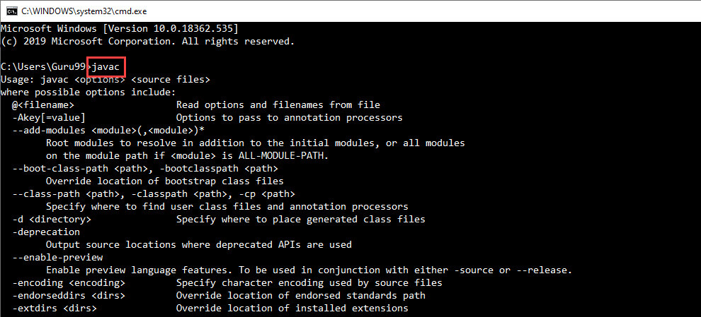](https://cdn.guru99.com/images/java/1912211_install_javaimage15.jpg)